**DAILY ONLINE ACTIVITIES SUMMARY**

|  |  |  |  |  |  |  |  |  |
| --- | --- | --- | --- | --- | --- | --- | --- | --- |
| **Date:** | **18-05-2020** | | | | | **Name:** | **Preethi** | |
| **Sem & Sec** | **6th - B** | | | | | **USN:** | **4AL17CS065** | |
| **Online Test Summary** | | | | | | | | |
| **Subject** | | **CNSC** | | | | | | |
| **Max. Marks** | | **60** | | **Score** | | | **48** | |
| **Certification Course Summary** | | | | | | | | |
| **Course** | **Machine Learning Onramp** | | | | | | | |
| **Certificate Provider** | | | **MathWorks** | | **Duration** | | | **2 hrs** |
| **Coding Challenges** | | | | | | | | |
| **Problem Statement: Two java programs and 2 C programs** | | | | | | | | |
| **Status: executed** | | | | | | | | |
| **Uploaded the report in GitHub** | | | | | **yes** | | | |
| **If yes Repository name** | | | | | https://github.com/PreethiNayak/Daily-Status/tree/master/18May2020 | | | |
| **Uploaded the report in slack** | | | | | **Yes** | | | |

Online Test Details: (Attach the snapshot and briefly write the report for the same)

First I A of CNSC

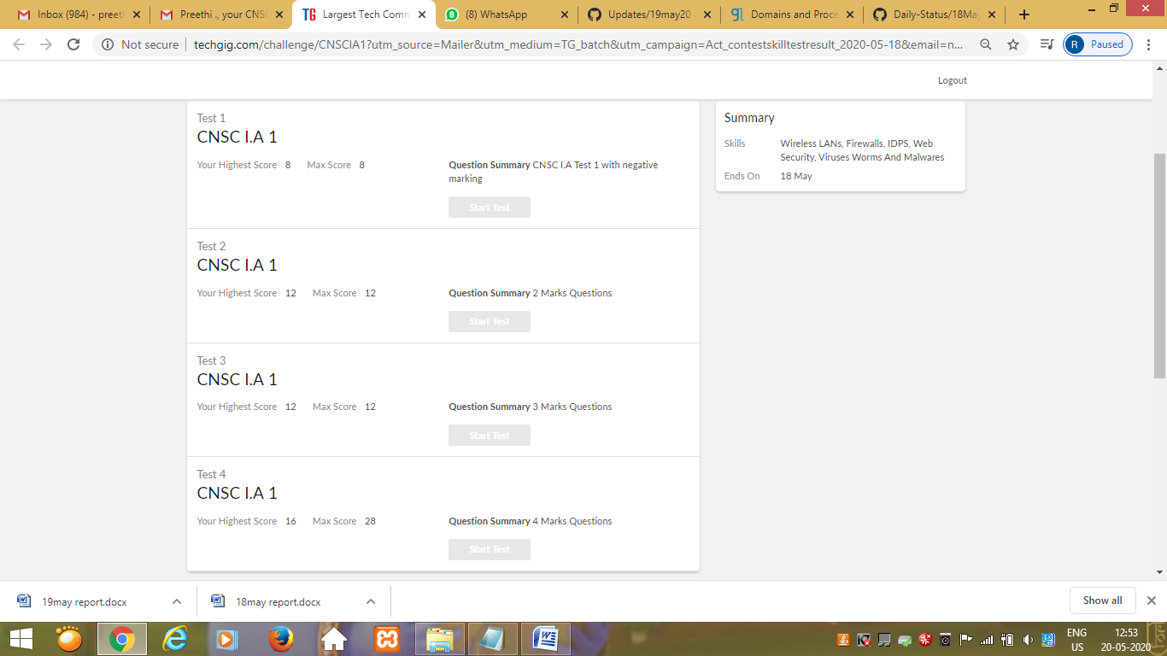

Certification Course Details: (Attach the snapshot and briefly write the report for the same)

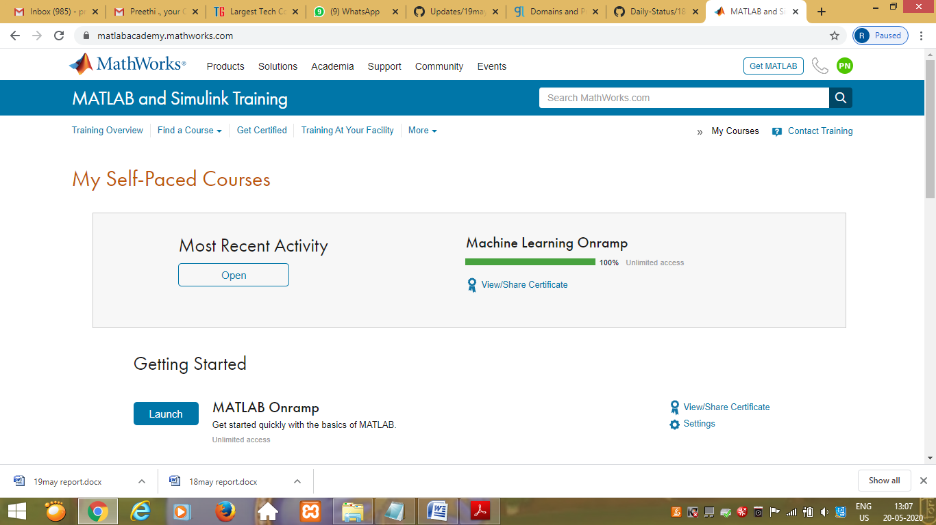

Coding Challenges Details: (Attach the snapshot and briefly write the report for the same)

OUTPUT SCREEN-SHOTS

Program 1(count)

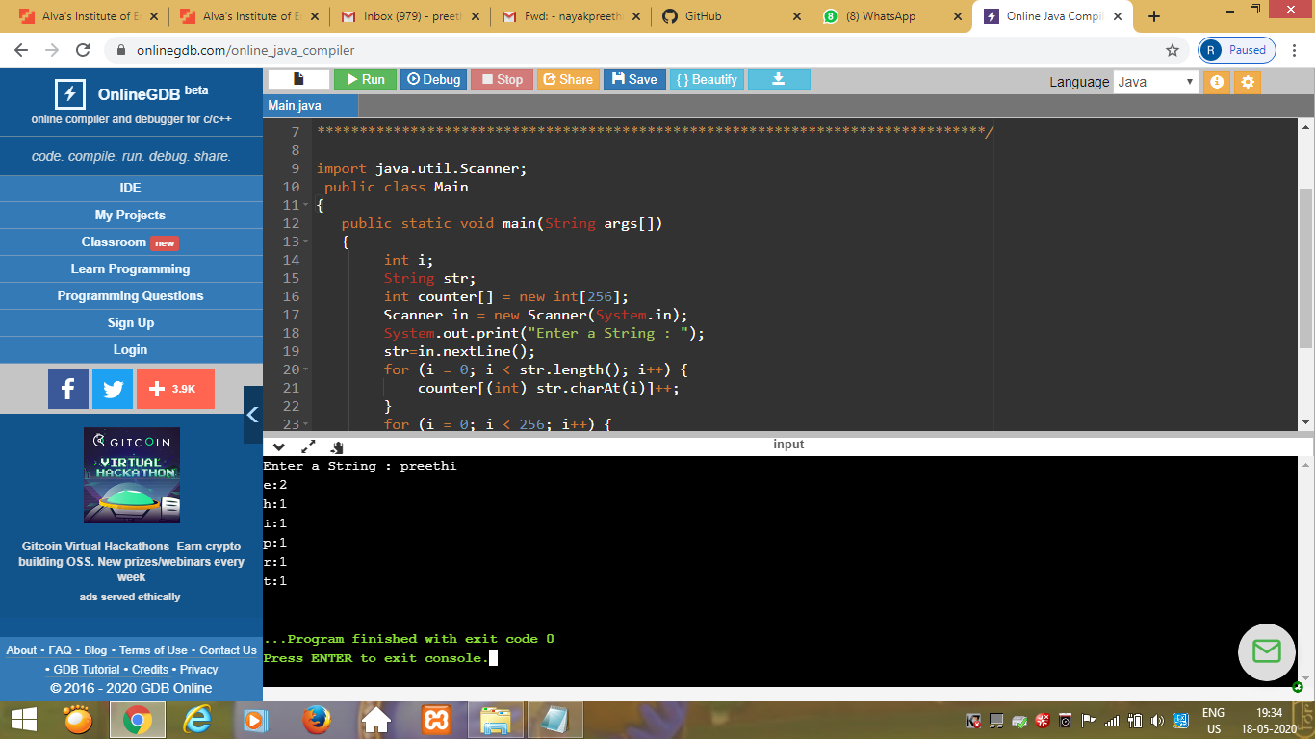

Program 2(ping pong)

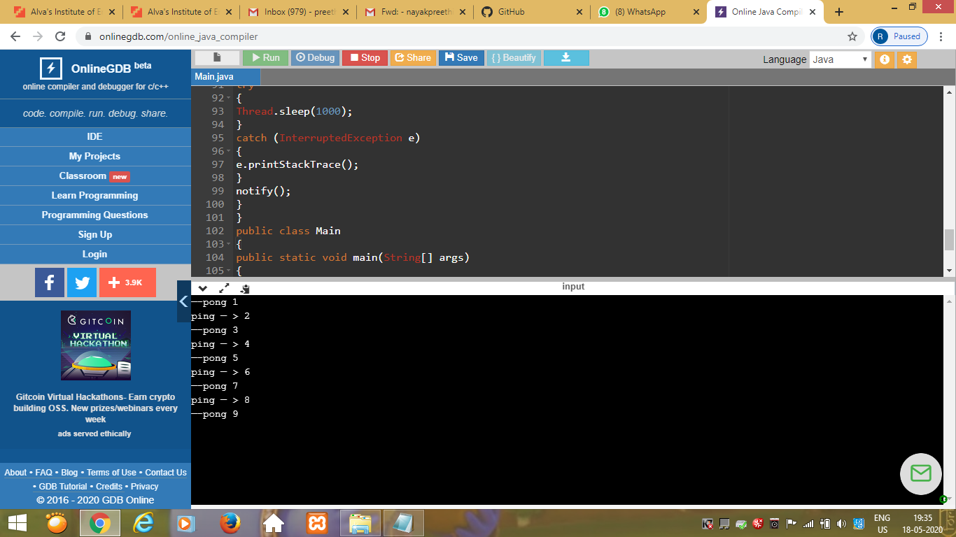  
Program 3

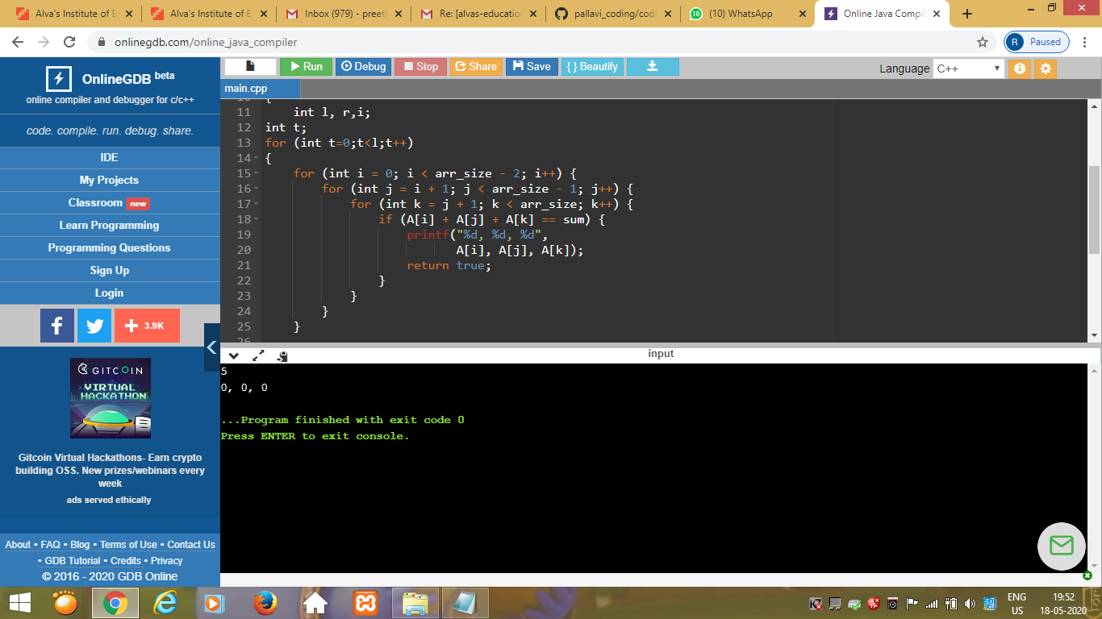

Program 4

